CENWP-OP-B
15 July 2003
MEMORANDUM FOR THE RECORD

SUBJECT: Dead chinook at Bonneville’s Adult Fish Facility (AFF).

- Project biologists were informed about a chinook mortality that occurred around 1200 on 15 July 2003.
- The clipped chinook had been worked up by CRITFC and released to the brail pool to recover but failed to do so.
- There were no signs of injury and the gills were still a reddish color when examined at 1300 on 15 July.
- The fish was discarded through the glory hole.
- Photos are attached.

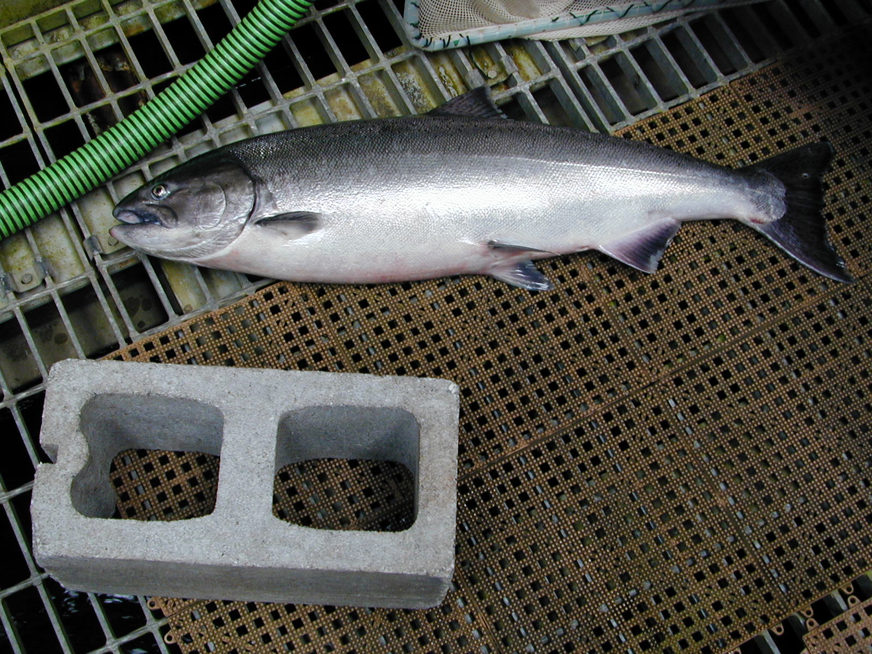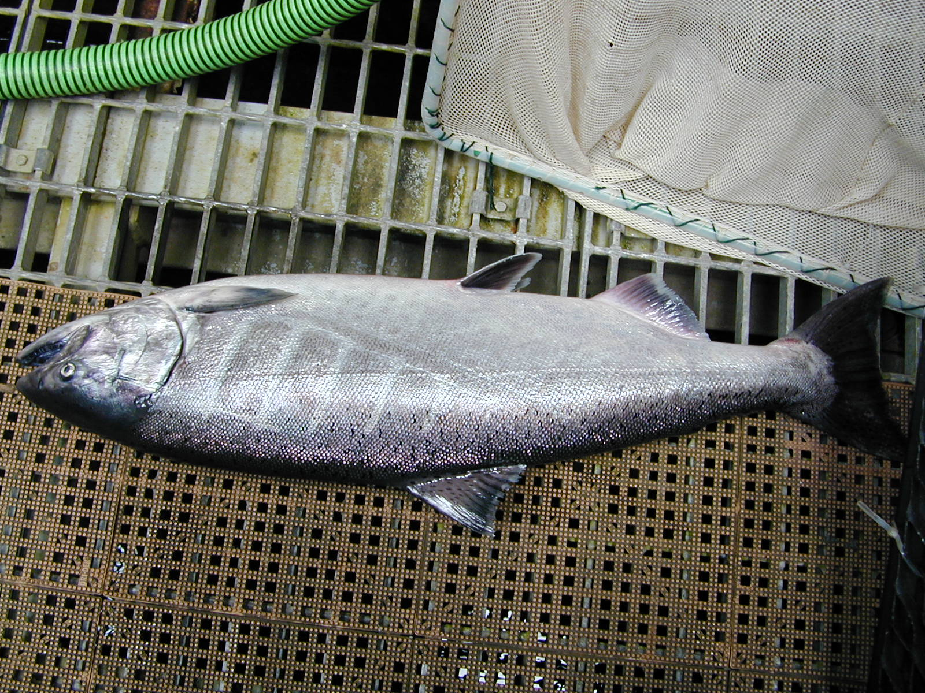

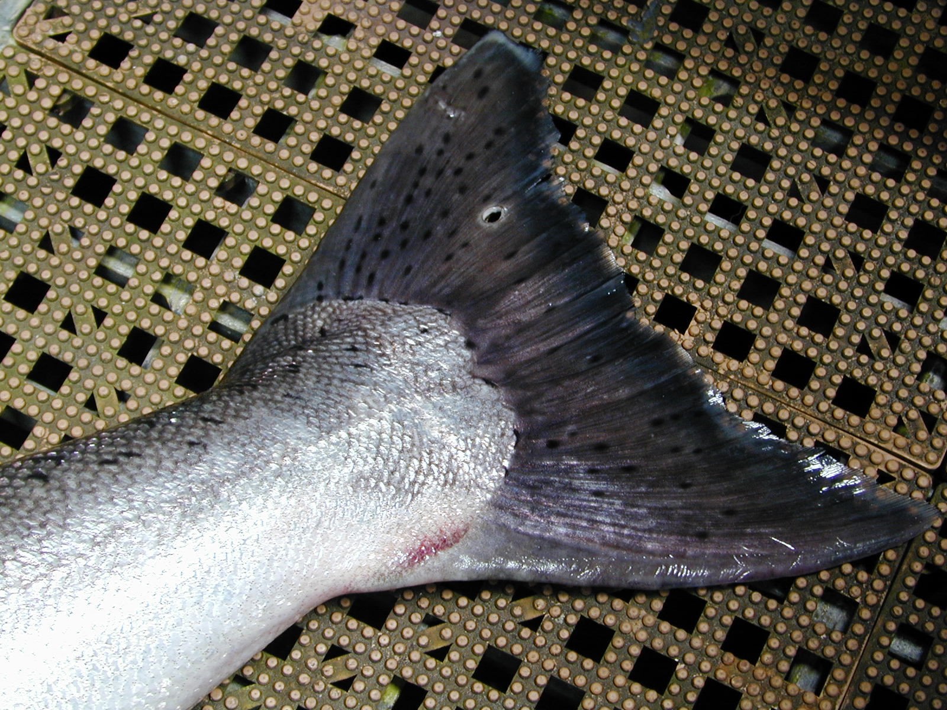

Tammy Mackey
Bonneville Fisheries Biologist

